Module 1 – Overview of IT Industry

What is Program?
1. What is Programming?
- Programming is to create a Program.

What is Programming?
2.What are the key steps in involved in the Programming Process?
- The key steps in involved in The Programming Process are:
The programming process is a systematic approach used to develop a software program. It ensures that the solution is correct, efficient, and easy to maintain.
- Problem Definition
Understand the problem clearly
Identify inputs, outputs, and requirements
- 2. Planning (Algorithm / Flowchart)
Design the solution before coding
Use algorithms (step-by-step logic) or flowcharts (diagram)
- 3. Coding (Implementation)
Write the program using a language like C programming language or Python
Follow proper syntax and logic
- 4. Compilation / Execution
Convert code into machine-readable form
Run the program to check output
- 5. Testing and Debugging
Identify and fix errors (bugs)
Ensure correct results
- 6. Documentation
Write details about the program (code, usage)
Helps others understand and maintain it
- 7. Maintenance
Update and improve the program after deployment
Fix new issues and add features
3.What are the main differences between high-level and low-level programming languages?

High-level Language | Low-level Language
Easy to understand, human-readable | Close to machine, hardware-dependent
Abstract (far from hardware) | Abstract (far from hardware)
Easy to write, read, and maintain | Difficult to write and understand
Portable (runs on different systems) | Not portable (machine-specific)
Slower compared to low-level | Faster execution
Ex-C programming language, Java, Python | Ex-Machine Language, Assembly Language

World Wide Web & How Internet Works
4.Describe the roles of the client and server in web communication.
- Client (User Side)
- The client is the device or application that requests data/services
- Usally a web browser like Google Chrome or Mozilla Firefox
- Sends an HTTP request to the server
- Receives response and displays it to the user
- Example: You open a website → your browser sends request
Server (Provider Side)
- The server stores and processes data
- Handles client requests and sends back response
- Uses web server software like Apache HTTP Server
- Example: Server sends HTML, CSS, data to your browser

Network Layers on Client Server Communication
5. Explain the function of the TCP/IP model and its layers.

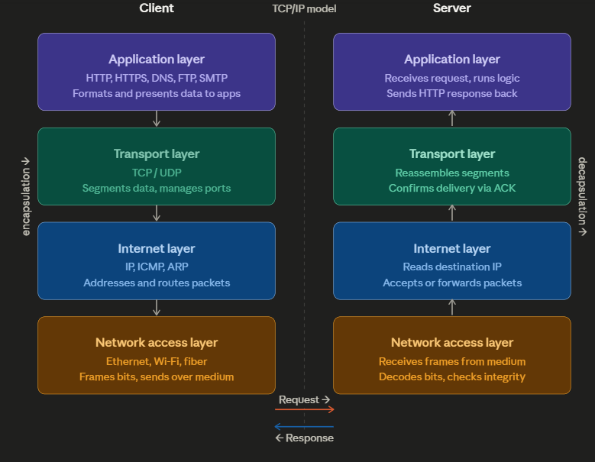
- The four layers :
Application layer — the topmost layer, where user-facing protocols live. When you type a URL, your browser uses HTTP (or HTTPS) to build a request message. The server's application layer is where that request lands, is interpreted, and a response is generated. Other protocols at this layer include DNS (translating domain names to IP addresses), FTP (file transfer), and SMTP (email).
Transport layer — responsible for breaking the application message into smaller chunks called segments, and for ensuring they arrive reliably and in order. TCP (Transmission Control Protocol) is the dominant protocol here — it assigns port numbers to identify which application should receive the data, performs a three-way handshake to establish a connection, and sends acknowledgements (ACKs) so the sender knows what was received. UDP is the lighter alternative when speed matters more than guaranteed delivery (e.g., video streaming, gaming).
Internet layer — handles addressing and routing. Each segment is wrapped in a packet with source and destination IP addresses attached. Routers across the internet read only this layer, forwarding each packet hop-by-hop toward the destination without needing to understand what's inside. The key protocol here is IP (Internet Protocol), along with ICMP (used for diagnostics like ping) and ARP (mapping IP addresses to physical MAC addresses).
Network access layer — the bottom layer, dealing with the physical transmission of data on a specific medium (Ethernet cable, Wi-Fi, fibre optic). It frames the packets into bits and handles MAC addressing for local delivery. On the receiving server, this layer picks up the raw signal and passes decoded bits upward.

Client and Servers
6.Explain Client Server Communication .

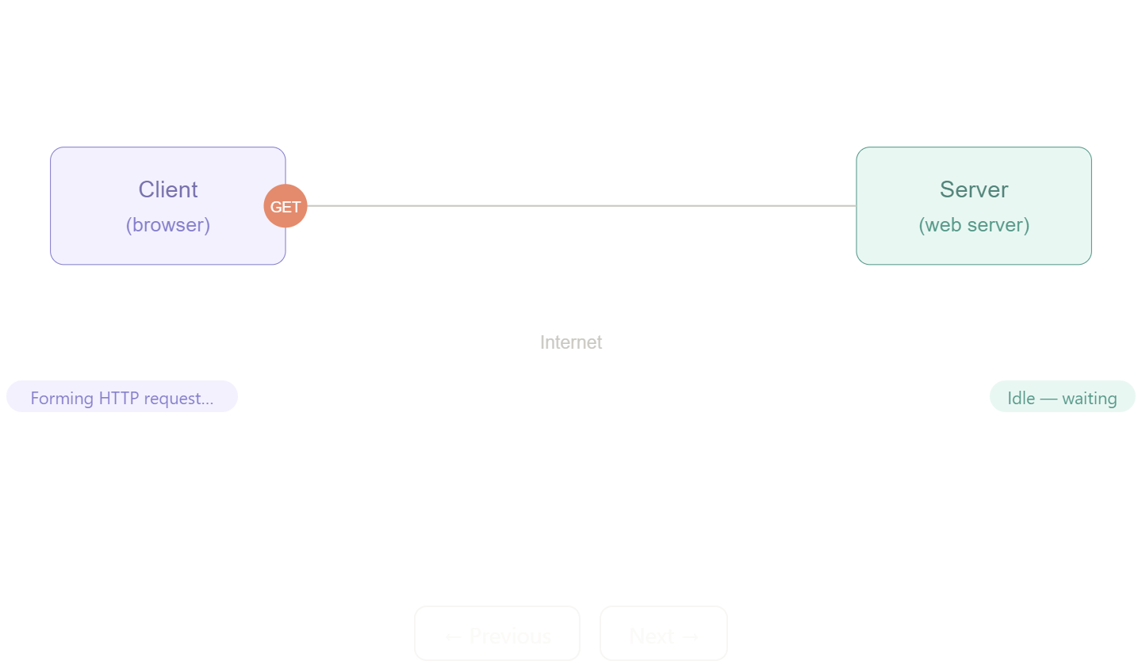
What is client-server communication?
It is a model where two types of computers have clearly defined roles. The client is any device that requests a service — a browser on your laptop, a mobile app, or even another server. The server is a computer that waits for requests, processes them, and sends back a response. Communication between them always follows a strict request-response pattern: the client always initiates, and the server always reacts.

Types of Internet Connections
7.How does broadband different from fiber-optic internet?
- How broadband works:
Cable and DSL broadband transmit data as electrical signals through copper wire. Copper has been in the ground for decades — it was originally laid for telephone and cable television — which is why broadband is so widely available. Providers reused this existing infrastructure rather than building from scratch.
The limitation of copper is physics: electrical signals lose strength as they travel. The further you are from the telephone exchange or cable node, the weaker (and therefore slower) your signal. This is why two houses on the same street can have noticeably different broadband speeds. Copper also carries interference from nearby electrical equipment. And because sending and receiving signals over copper at high speeds is technically harder in one direction than the other, broadband connections are typically asymmetric — download speeds are much higher than upload speeds
How fiber-optic works:
Fiber-optic cables transmit data as pulses of light through strands of glass or plastic thinner than a human hair. Light travels at roughly 200,000 km per second through glass, and it does not degrade the way electrical signals do over copper. A signal can travel dozens of kilometres through a fiber cable with almost no loss in strength.

Protocols
8.What are the differences between HTTP and HTTPS protocols?

Feature | HTTP | HTTPS
Full Form | HyperText Transfer Protocol | HyperText Transfer Protocol Secure
Security | Not secure | Secure (encrypted)
Encryption | No encryption | Uses encryption (SSL/TLS)
Data Safety | Data can be intercepted | Data is protected
Port Number | 80 | 443
URL Format | http:// | https://
Use Case | Normal websites | Banking, login, payments

Application Security
9. What is the role of encryption in securing applications?
- Role of Encryption in Securing Applications:
Encryption is the process of converting data into a coded form so that only authorized users can read it. It’s one of the core building blocks of application security.
1. Protects Data Confidentiality
- Keeps sensitive data (passwords, personal info) hidden
- Even if data is intercepted, it cannot be understood
2. Secures Data in Transit
- Protects data while it travels between client and server
- Used in HTTPS with TLS
- Example: Login details sent over a website stay encrypted
3. Ensures Data Integrity
- Prevents unauthorized modification of data
- If data is changed during transfer, it can be detected
4. Provides Authentication
- Helps verify identity of users and servers
- Ensures you are communicating with the correct system
5. Protects Stored Data (Data at Rest)
- Encrypts data stored in databases or devices
- Useful if system is hacked or stolen

Software Applications and Its Types

10. What is the difference between system software and application software?

Feature | System Software | Application Software
Purpose | Manages hardware and system operations | Performs specific user tasks
User Interaction | Works in background | Directly used by users
Dependency | Essential for running system | Depends on system software
Examples | Windows operating system, device drivers | Microsoft Word, Google Chrome
Function | Controls memory, CPU, devices | Helps in tasks like writing, browsing
Installation | Installed first | Installed after system software

Software Architecture
11. What is the significance of modularity in software architecture?
- Significance of Modularity in Software Architecture:
Modularity is a design approach in which a software system is divided into smaller, independent units called modules. Each module performs a specific function and can be developed and managed separately.
The significance of modularity is very important in software architecture. First, it improves understandability, as complex systems are broken into simpler parts. Second, it makes maintenance easier, because changes in one module do not affect the entire system. Third, modularity promotes reusability, allowing developers to reuse modules in different projects, saving time and effort.
Additionally, it supports parallel development, where multiple developers can work on different modules simultaneously. It also improves testing and debugging, since errors can be identified and fixed within individual modules. Lastly, modular systems are more scalable, as new features can be added by creating new modules without disturbing existing ones.

Layers in Software Architecture
12.Why are layers important in software architecture?
- Layers are important in software architecture because they divide a system into separate sections, where each layer performs a specific function. This structured approach makes software easier to design and manage.
- Firstly, layers improve organization by separating different parts of the system such as user interface, business logic, and data handling. This makes the system more clear and systematic.
- Secondly, layers provide separation of concerns, meaning each layer focuses on its own task without interfering with others. This reduces complexity and confusion.
- Thirdly, layered architecture makes maintenance easier. If any change is required, it can be done in one layer without affecting the entire system.
- It also improves reusability, as certain layers (like data access or business logic) can be reused in other applications.
- Another advantage is security, since sensitive operations can be handled in specific layers, reducing risk.
- Additionally, layers support scalability and flexibility, allowing developers to modify or expand the system easily.

Software Environments
13. Explain the importance of a development environment in software production.
- A development environment is a set of tools and software used by developers to write, test, and manage code. It typically includes an editor/IDE, compiler or interpreter, debugger, and version control tools.
- The importance of a development environment in software production is significant. First, it improves productivity by providing features like code suggestions, syntax highlighting, and auto-completion, which help developers write code faster and with fewer errors. Tools like Visual Studio Code make coding more efficient.
- Second, it helps in error detection and debugging. Built-in debugging tools allow developers to find and fix errors quickly, improving software quality.
- Third, it ensures consistency across development, testing, and deployment. Using the same environment reduces compatibility issues and unexpected behavior.
- Another key benefit is collaboration. With version control systems like Git, multiple developers can work on the same project without conflicts.
- It also supports testing and integration, allowing developers to test code frequently and integrate changes smoothly.
- Finally, a good development environment improves software quality and reliability, as it provides tools for proper coding, testing, and maintenance.

Source Code
14. What is the difference between source code and machine code?

Feature | Source Code | Machine Code
Definition | Human-readable code written by programmer | Binary code understood by computer
Language Form | High-level languages like C programming language, Python | 0s and 1s (binary)
Readability | Easy to read and understand | Difficult for humans to understand
Execution | Cannot run directly | Executed directly by CPU
Conversion | Needs compiler/interpreter | Final converted form
Error Detection | Errors can be easily found | Hard to detect errors

Github and Introductions
15. Why is version control important in software development?
- Version control is a system that helps developers track and manage changes in source code over time. Tools like Git are commonly used for this purpose.
- Version control is important in software development for several reasons. First, it allows developers to keep a history of changes, so they can easily see what modifications were made and when. If something goes wrong, they can revert to a previous version, which reduces the risk of losing work.
- Second, it supports team collaboration. Multiple developers can work on the same project simultaneously without overwriting each other’s code. Version control systems manage these changes efficiently through branches and merges.
- Third, it improves code management and organization. Developers can create different versions (branches) for new features or bug fixes without affecting the main code.
- Another important benefit is backup and recovery. Since the code is stored in repositories, it acts as a backup and protects against data loss.
- It also enhances accountability, as every change is recorded with the developer’s name and details, making it easier to track contributions and errors.

Student Account in Github

16. What are the benefits of using Github for students?
- Benefits of Using GitHub for Students:
- GitHub is a platform that helps students store, manage, and share their code using version control.
- Using GitHub offers many advantages for students:
- First, it helps in code storage and backup. Students can save their projects online, so their work is safe even if their system fails.
- Second, it improves version control. Students can track changes in their code, go back to previous versions, and manage updates easily.
- Third, GitHub supports collaboration. Multiple students can work on the same project, making it useful for group assignments and teamwork.
- Another important benefit is portfolio building. Students can showcase their projects on GitHub, which helps during internships and job placements.
- It also helps in learning and practice. Students can explore other developers’ code, understand real-world projects, and improve their skills.
- Additionally, GitHub encourages open-source contribution, where students can contribute to real projects and gain practical experience.

Types of Software
17. What are the differences between open-source and proprietary software?

Feature | Open-Source Software | Proprietary Software
Source Code | Available to everyone | Not available to public
Modification | Can be modified freely | Cannot be modified
Cost | Usually free | Usually paid/licensed
Control | Community-driven | Controlled by company
Flexibility | Highly flexible | Limited flexibility
Security | Transparent (can be reviewed) | Depends on company
Examples | Linux, Mozilla Firefox | Microsoft Windows, Microsoft Office

GIT and GITHUB Training
18.How does GIT improve collaboration in a software development team?
- Git is a distributed version control system that helps multiple developers work together on the same project efficiently.
- Git improves collaboration in several important ways. First, it allows multiple developers to work simultaneously on the same codebase without interfering with each other. Each developer can create their own branch and work independently.
- Second, Git provides branching and merging features. Developers can create branches for new features or bug fixes and later merge them into the main project without affecting ongoing work.
- Third, it maintains a complete history of changes. Every modification is recorded with details such as who made the change and when, which helps in tracking progress and resolving issues.
- Git also supports easy conflict resolution. If multiple developers modify the same part of the code, Git highlights conflicts so they can be resolved properly.
- Another benefit is backup and reliability. Since Git is distributed, every developer has a copy of the project, reducing the risk of data loss.
- Additionally, platforms like GitHub enhance collaboration by providing features like pull requests, code reviews, and issue tracking.

Application Software
19. What is the role of application software in businesses?
- Application software plays a crucial role in modern businesses by helping organizations perform specific tasks efficiently and effectively. These software programs are designed to support various business operations such as data processing, communication, accounting, and decision-making.
1. Automation of Business Processes
Application software helps automate routine tasks like billing, payroll, inventory management, and report generation. This reduces manual effort, saves time, and minimizes human errors.
2. Improved Productivity and Efficiency
By using tools like Microsoft Excel and Microsoft Word, employees can perform tasks faster and more accurately, leading to increased productivity.
3. Data Management and Storage
Businesses generate large amounts of data. Application software helps in storing, organizing, and retrieving this data efficiently using databases and management systems.
4. Better Communication and Collaboration
Applications such as Gmail enable quick communication between employees, departments, and clients, improving coordination and teamwork.
5. Decision-Making Support
Application software provides analytical tools, reports, and insights that help managers make informed business decisions based on accurate data.
6. Customer Relationship Management
CRM applications help businesses manage customer data, track interactions, and improve customer satisfaction by providing better services.
7. Financial Management
Accounting software helps in managing financial transactions, budgeting, and auditing, ensuring accuracy and transparency.
8. Scalability and Flexibility
Application software allows businesses to expand their operations easily by adding new features or upgrading systems as needed.
9. Security and Data Protection
Modern applications include security features that protect sensitive business information from unauthorized access.

Software Development Process
20. What are the main stages of the software development process?
- Main Stages of the Software Development Process (SDLC)
The software development process, often called the Software Development Life Cycle (SDLC), consists of several stages used to design, develop, and maintain software in a systematic way.
1. Requirement Analysis
In this stage, the needs and expectations of users are collected and analyzed.
- Identify what the software should do
- Define inputs, outputs, and features
- Prepare requirement documents
2. System Design
The overall structure of the software is planned.
- Decide architecture (modules, components)
- Design database and user interface
- Create system design documents
3. Implementation (Coding)
Actual coding of the software is done in this stage.
- Developers write programs using languages like C programming language or Python
- Convert design into working code
4. Testing
The developed software is tested to find errors and bugs.
- Unit testing, integration testing, system testing
- Ensure software works correctly
5. Deployment
The software is released for users.
- Installed on user systems or servers
- Made available for real-world use
6. Maintenance
After deployment, the software is updated and improved.
- Fix bugs
- Add new features
- Improve performance
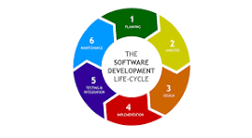

Software Requirement
21. Why is the requirement analysis phase critical in software development?
- The requirement analysis phase is the first and most important stage of the Software Development Life Cycle (SDLC). In this phase, the needs and expectations of users are carefully gathered, analyzed, and documented. It acts as the foundation for the entire software project.
1. Clear Understanding of Requirements
This phase helps developers understand what the user actually needs. Without clear requirements, the software may not meet user expectations.
2. Reduces Errors and Rework
If requirements are properly defined at the beginning, it reduces mistakes in later stages like design and coding. This saves time, effort, and cost.
3. Provides Direction for Development
Requirement analysis gives a clear roadmap for developers, helping them design and build the system correctly.
4. Improves Communication
It ensures proper communication between clients, developers, and stakeholders, avoiding misunderstandings.
5. Helps in Accurate Planning
Based on requirements, teams can estimate time, cost, and resources needed for the project.
6. Enhances Software Quality
Well-defined requirements lead to better design and implementation, resulting in high-quality software.
7. Basis for Testing
Requirements act as a reference for testing. Test cases are created based on these requirements to check whether the software works correctly.
8. Avoids Project Failure
Many projects fail due to unclear or incorrect requirements. This phase reduces such risks significantly.

Software Analysis
22. What is the role of software analysis in the development process?
- Software analysis is a crucial phase in the Software Development Life Cycle (SDLC) where the requirements of the system are studied, understood, and organized in detail. It acts as a bridge between the user’s needs and the actual system design.
1. Understanding User Requirements
Software analysis helps in clearly identifying what the user wants from the system. It gathers both functional requirements (what the system should do) and non-functional requirements (performance, security, etc.).
2. Problem Identification and Clarification
It helps in analyzing the problem deeply and removing confusion or ambiguity. This ensures that developers build the correct solution.
3. Requirement Documentation
All requirements are properly documented in formats like Software Requirement Specification (SRS), which serves as a reference for the entire project.
4. Feasibility Study
Software analysis includes checking whether the project is technically, economically, and operationally feasible before development starts.
5. Provides Basis for Design
The output of software analysis is used to design the system architecture, modules, and database structure.
6. Improves Communication
It ensures clear communication between clients, developers, and stakeholders, reducing misunderstandings.
7. Reduces Risk and Errors
Proper analysis minimizes the chances of errors in later stages like coding and testing, saving time and cost.
8. Supports Testing and Validation
Requirements defined during analysis are used to create test cases and verify whether the system meets expectations.

System Design
23. What are the key elements of system design?
- System design is the phase where the overall structure of a software system is planned. It defines how different components will work together to meet user requirements.
1. Architecture Design
Defines the overall structure of the system
Decides how components interact (e.g., client-server, layered architecture)
2. Data Design
Organizes how data is stored and managed
Includes database structure, tables, relationships
Uses database systems like MySQL
3. Interface Design
Defines how users interact with the system
Includes input forms, screens, and output displays
4. Component (Module) Design
Breaks system into smaller modules
Each module performs a specific function
5. Process Design
Describes how data flows and how processes are executed
Defines algorithms and workflows
6. Security Design
Ensures protection of data and system
Includes authentication, authorization, encryption
7. Deployment Design
Decides how the system will be installed and run
Includes hardware, servers, and network setup
8. Performance Design
Ensures system works efficiently
Focus on speed, scalability, and resource usage

Software Testing
24. Why is software testing important?
- Software testing is a process of evaluating a software system to identify errors, bugs, and defects. It ensures that the software works correctly and meets user requirements before it is delivered.
1. Detects Errors and Bugs
Testing helps find mistakes in the software so they can be fixed before release, improving reliability.
2. Ensures Quality
It ensures the software meets required standards and performs as expected under different conditions.
3. Improves User Satisfaction
A well-tested application provides a smooth user experience, increasing customer satisfaction and trust.
4. Verifies Requirements
Testing checks whether the software meets the requirements defined during analysis.
5. Enhances Security
Testing identifies vulnerabilities and security issues, helping protect data from unauthorized access.
6. Reduces Cost
Fixing bugs early in testing is cheaper than fixing them after deployment.
7. Ensures Performance
Testing checks speed, responsiveness, and stability of the system under load.
8. Supports Reliability and Stability
It ensures the system runs without crashing or failing during real use.
9. Helps in Risk Reduction
Testing minimizes the chances of software failure, which can cause loss to business.

Maintenance
25. What types of software maintenance are there?
- Software maintenance refers to the process of modifying and updating software after it has been deployed to ensure it continues to function effectively and efficiently. It is an important phase of the Software Development Life Cycle (SDLC) that helps in improving performance, fixing errors, and adapting to new requirements.
There are four main types of software maintenance:
1. Corrective Maintenance
Corrective maintenance is performed to fix errors and bugs discovered after the software is in use. These issues may affect functionality or performance and need to be corrected to ensure smooth operation.
Example: Fixing calculation errors in a billing system.
2. Adaptive Maintenance
Adaptive maintenance involves modifying the software to adapt to changes in the environment such as new hardware, operating systems, or technologies.
Example: Updating software to run on a new version of Windows operating system.
3. Perfective Maintenance
Perfective maintenance focuses on enhancing the system by adding new features or improving existing ones. It helps in increasing performance, usability, and efficiency based on user feedback.
Example: Adding new reports or improving the user interface of an application.
4. Preventive Maintenance
Preventive maintenance is done to prevent future problems by improving code quality and system structure. It reduces the chances of failures and makes the software easier to maintain.
Example: Code optimization and restructuring.

Development
26. What are the key differences between web and desktop applications?

Feature | Web Applications | Desktop Applications
Definition | Runs inside a web browser | Installed and runs on a computer
Installation | No installation required | Must be installed on device
Internet Requirement | Usually requires internet | Can work offline
Platform Dependency | Platform-independent (works on any OS with browser) | Platform-dependent (Windows, Mac, etc.)
Performance | Depends on internet and browser | Faster, uses local system resources
Updates | Automatic (server-side updates) | Manual updates needed
Accessibility | Accessible from anywhere | Limited to installed device
Security | Depends on web security (HTTPS, etc.) | More control over local security
Examples | Gmail, Facebook | Microsoft Word, Adobe Photoshop

Web Application
27. What are the advantages of using web applications over desktop applications?
- Web applications are programs that run in a browser and are accessed through the internet. They offer several advantages compared to desktop applications.
1. No Installation Required
Web applications do not need to be installed on a device. Users can access them directly through a browser, saving time and storage space.
2. Platform Independence
They can run on any operating system (Windows, Linux, macOS) as long as a browser is available, making them highly flexible.
3. Easy Accessibility
Users can access web applications from anywhere and any device with an internet connection.
Example: Gmail can be accessed from phone, laptop, or tablet.
4. Automatic Updates
Updates are managed on the server side, so users always get the latest version without manual installation.
5. Better Collaboration
Multiple users can work on the same application simultaneously, making it ideal for teamwork and group projects.
6. Cost-Effective
No need for installation or maintenance on individual systems, reducing overall costs for businesses.
7. Data Backup and Security
Data is stored on servers, reducing the risk of data loss due to system failure. Security measures like HTTPS improve protection.
8. Low System Requirements
Web applications do not require high system specifications since most processing is done on the server.

Designing
28. What role does UI/UX design play in application development?
- UI/UX design plays a crucial role in application development by ensuring that the application is easy to use, visually appealing, and provides a good user experience.
- UI (User Interface) focuses on the look and layout of the application (buttons, colors, screens).
- UX (User Experience) focuses on how the user feels while using the application (ease, comfort, satisfaction).
1. Improves Usability
UI/UX design makes applications simple and easy to use, allowing users to perform tasks without confusion.
2. Enhances User Experience
A well-designed UX ensures users have a smooth and enjoyable experience, increasing satisfaction.
3. Increases User Engagement
Attractive UI design encourages users to spend more time on the application.
4. Reduces Errors
Good design guides users properly, reducing mistakes and improving efficiency.
5. Improves Accessibility
UI/UX ensures that applications are usable by different types of users, including beginners and people with disabilities.
6. Supports Business Goals
Better design leads to higher user retention, more usage, and improved business outcomes.
7. Saves Development Time and Cost
Proper UI/UX planning reduces the need for major changes later, saving time and money.
8. Builds Brand Image
A well-designed application creates a positive impression and strengthens brand identity.

Mobile Application
29. What are the differences between native and hybrid mobile apps?

Feature | Native Mobile Apps | Hybrid Mobile Apps
Definition | Built specifically for one platform (Android or iOS) | Built using web technologies and run inside a container
Technology Used | Platform-specific languages (Java/Kotlin, Swift) | HTML, CSS, JavaScript
Performance | High performance and fast | Slightly slower than native
User Experience | Best UI/UX, smooth and responsive | Good but not as smooth as native
Development Cost | Higher (separate apps for each platform) | Lower (single codebase)
Code Reusability | Low | High
Access to Device Features | Full access (camera, GPS, etc.) | Limited or via plugins
Maintenance | More effort (multiple versions) | Easier (one codebase)
Examples | WhatsApp, Instagram | Apps built using frameworks like Ionic

DFD (Data Flow Diagram)
30. Create a DFD for a hospital management system.
- Data Flow Diagram (DFD) for Hospital Management System
A Data Flow Diagram (DFD) represents how data moves through a system. It shows:
- External Entities (who interacts)
- Processes (what happens)
- Data Stores (where data is saved)
- Data Flow (movement of data)

Level 0 DFD
The DFD level 0, also known as context diagrams, is the most typical and understandable DFDs. This DFD level primarily concerns high-level system operations and the data sources that flow to or from them.
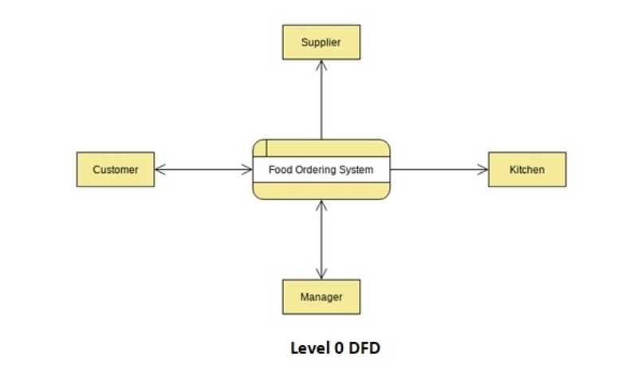
Level 1 DFD
The DFD level 1 provides a more in-depth look at the system by displaying the key sub-processes that comprise the system.

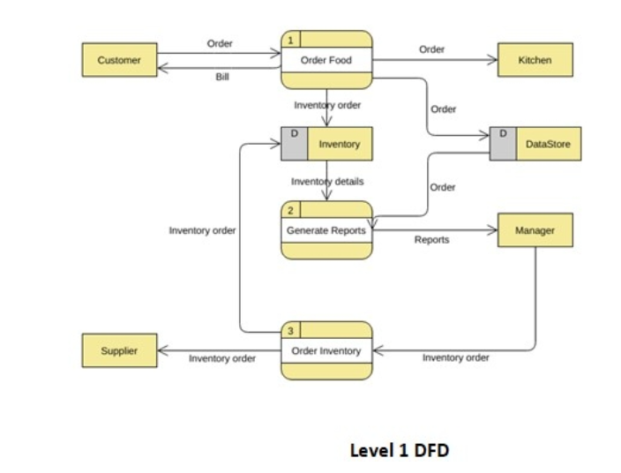
Level 2 DFD
Each level 1 process is divided into minutely detailed sub-processes in the next level of DFDs, which goes even further into detail. More text, symbols, and shapes are required to describe how the system works.

Desktop Application
31. What are the pros and cons of desktop applications compared to web applications?

- Desktop applications:
A desktop application is software installed directly onto a computer's operating system. Examples include Microsoft Word, Adobe Photoshop, VLC Media Player, and VS Code.
The greatest strength of a desktop app is performance and hardware access. Because the app runs natively on the operating system, it can use the full power of the CPU, GPU, RAM, and storage without any middleman. It can directly access the file system, connected devices (printers, microphones, cameras), and system-level features. This is why resource-heavy tools like video editors, CAD software, and games are still built as desktop apps — the browser simply cannot match this performance.
The major drawbacks are platform lock-in and distribution. A desktop app written for Windows typically cannot run on a Mac without being rewritten, which multiplies development cost and effort. Users must also download, install, and later update the software themselves, which creates friction and can lead to users running outdated versions.
- Web applications:
A web application runs inside a browser and requires no installation. Examples include Gmail, Google Docs, Trello, Figma, and Netflix.
The biggest advantage of a web app is universal reach. Write the application once and it works on Windows, Mac, Linux, and mobile — anything with a browser. Updates are instant and invisible to the user. This also makes collaboration far easier since all users are always on the same version and can share data in real time.
The limitations are performance and connectivity. The browser creates a sandbox — a protected environment that deliberately restricts what the app can do with your system. This is good for security but limits speed and hardware access. Web apps also depend on an internet connection, which makes them unreliable in areas with poor connectivity

Flow Chart
32. How do flowcharts help in programming and system design?

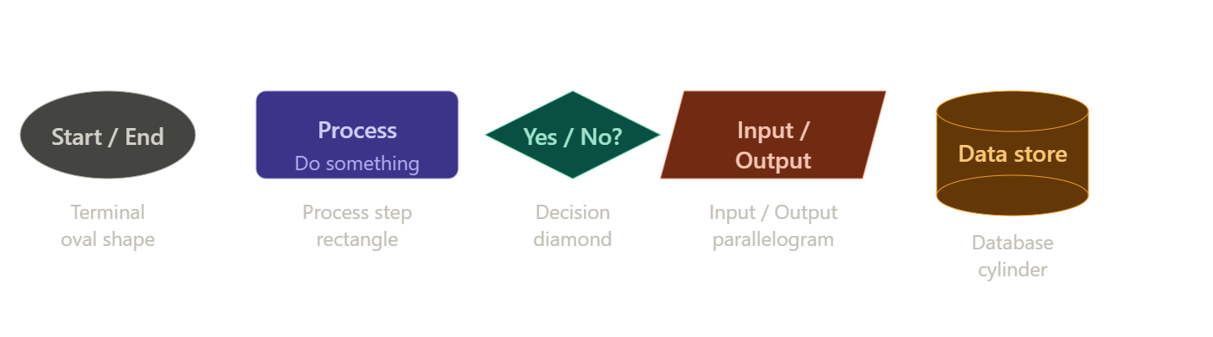
Now here is how those symbols combine in practice — a login system flowchart showing sequential steps, a decision branch, and a feedback loop.
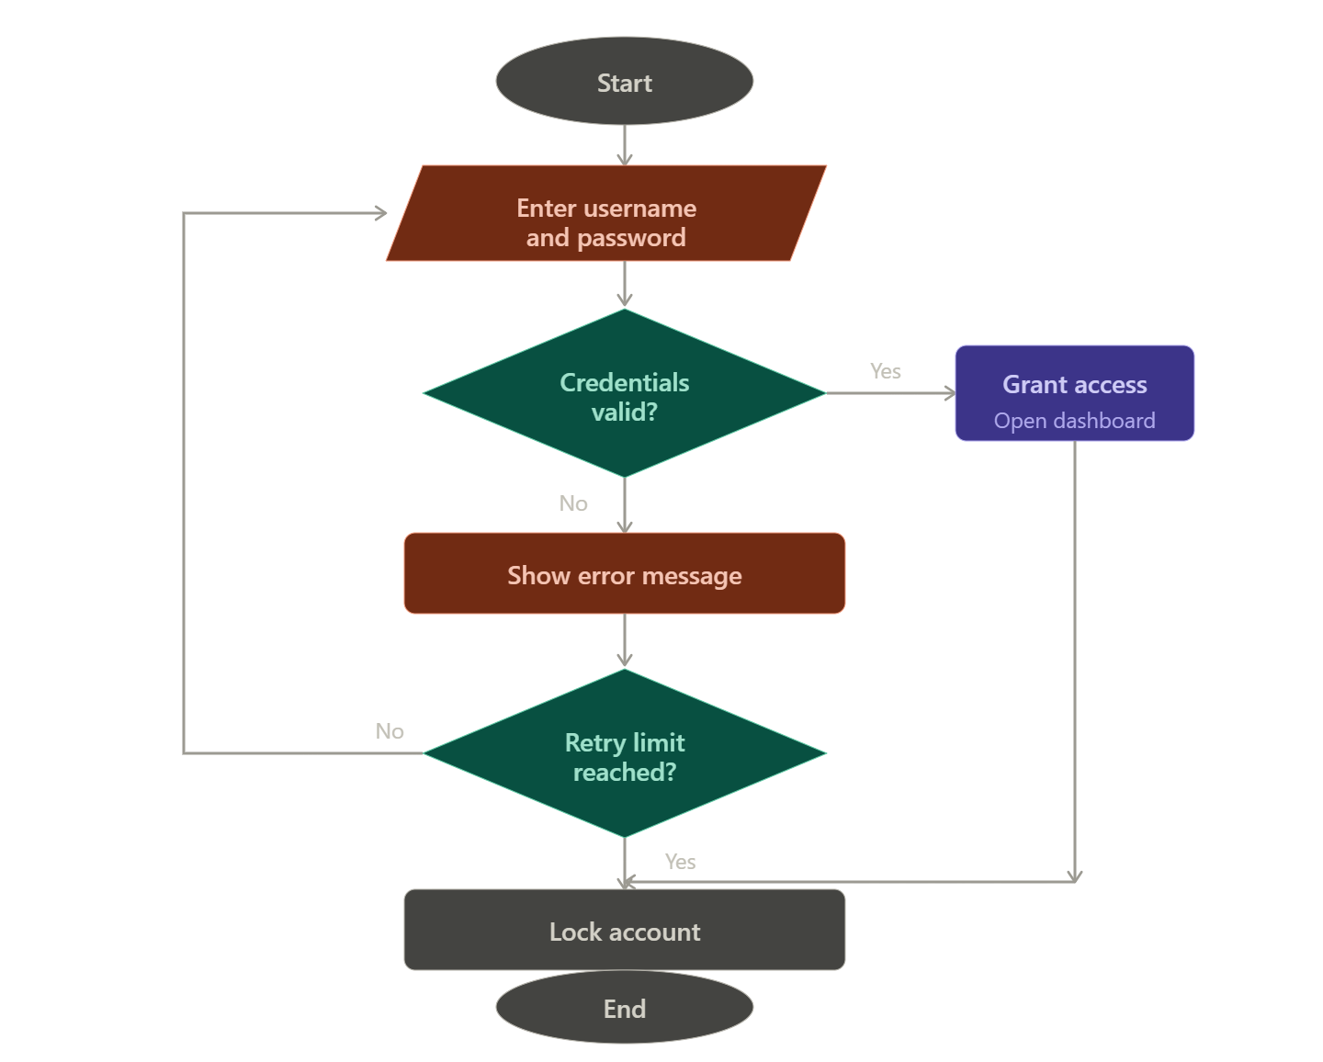
- How flowcharts help in programming
Clarifying logic before writing code. Writing code without a plan is like building without blueprints. A flowchart forces you to think through every path — including edge cases like "what happens if the user enters the wrong password three times?" — before you write a single line. Bugs caught at the diagram stage cost nothing to fix. Bugs found in finished code can take hours.
Making decisions visible. In code, a decision is written as if/else or switch — it blends into surrounding lines and is easy to miss. In a flowchart, every decision is a diamond shape with labelled exits, making the branching logic immediately obvious to anyone reading it. You can instantly see how many paths exist and where each leads.
Identifying loops and dead ends. Flowcharts expose infinite loops (arrows that cycle forever with no exit), unreachable code (steps that no arrow leads to), and missing outcomes (a decision with only one exit). These structural problems are hard to spot in code but jump out visually.
Communicating with non-programmers. A flowchart is language-neutral — a client, a manager, or a tester who doesn't know Python or Java can still follow a flowchart and verify that the logic matches what they want the system to do.

- How flowcharts help in system design
Planning entire systems before building them. Before designing a hospital management system or an e-commerce checkout, teams draw flowcharts of how data and users move through the system. This reveals which components need to talk to each other, where bottlenecks might appear, and what the system's boundaries are.
Documenting existing systems. Flowcharts are standard documentation tools. When a new developer joins a team, a flowchart of the system lets them understand how everything connects without reading thousands of lines of code. They are also invaluable for onboarding, audits, and compliance reviews.
Spotting inefficiencies. Drawing a process as a flowchart often reveals unnecessary steps, redundant decisions, or overly complex paths that can be simplified. Many organisations flowchart their business processes specifically to find where time and effort are being wasted.
Serving as a blueprint for multiple outputs. One well-drawn flowchart can guide the programmer writing code, the tester writing test cases (one test per path through the diagram), and the technical writer writing the user manual — all from the same source of truth.
- The three things every flowchart communicates at a glance
Sequence — what happens first, second, third. Decisions — where the flow branches based on a condition. Loops — where the flow repeats until a condition is met. These three concepts map directly to the three fundamental control structures in programming: sequence, selection (if), and iteration (for/while). Flowcharts are essentially a visual version of the same logic — which is exactly why they are so useful for planning code.

